Title: | Door Control Module  SW Component DigitalInputManager

History
Issue status  (Index) | Maturity/Date  (draft/invalid/valid)  (dd-mmm-yyyy) | Author  Department | Check/Release  Department | Description
1.0 | Draft  02-Feb-21 | Rubén Cocoletzi | - | Initial Version

Table of Contents
1 Purpose 3
2 Definitions and abbreviations 3
3 Realization constraints and targets 3
4 SW Conceptual design 4
5 SW Component internal breakdown 4
5.1 Functional Decomposition 4
5.2 Function void DigitalInputManager_ButtonWindowStates (void) 5
5.3 Function void DigitalInputManager_ButtonDoorStates (void) 6
5.4 Function void DigitalInputManager_SwitchStates (void) 7

Purpose
This document is created to show the principal behavior of the functions implemented in Door Control Module to read all digital inputs as well as implementing the debounce behavior.

Definitions and abbreviations
Definitions
NA

Abbreviations
BTN | Button
SysPwrMode | System Power Mode
References
N° | Document name | Reference
1 | SW Architecture description | Commit: ddc45822a03f9f1781eaa4fc5b6d5874311f8e1b

Realization constraints and targets

This document shows the principal implementation to read the digital inputs (switches and buttons)

SW Conceptual design
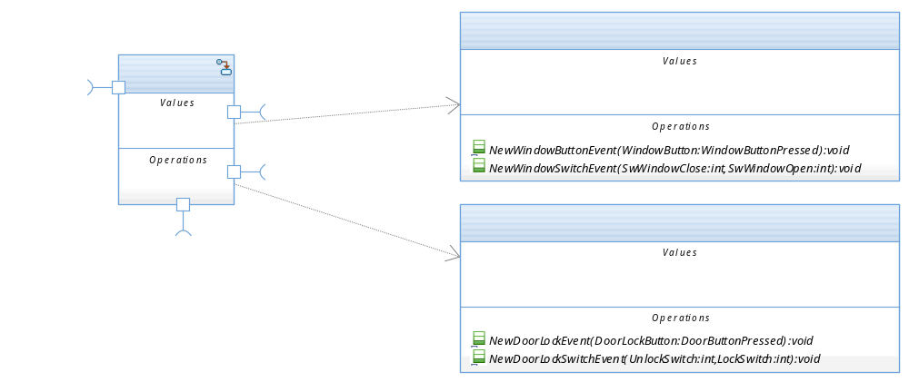

SW Component internal breakdown

Functional Decomposition
Overview of functions and their dependencies shown by a Static Function Tree
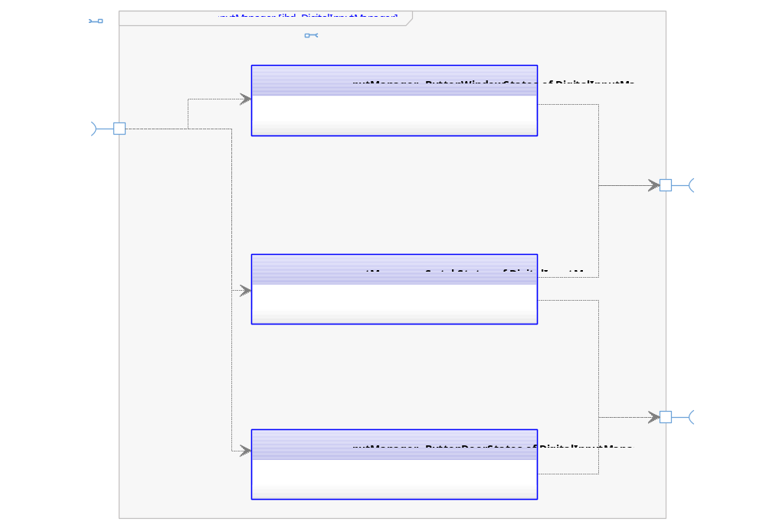

Function Description and Dynamic Behavior

Function void DigitalInputManager_ButtonWindowStates (void)

Description | This function is executed periodically. The execution is implemented with a state machine to show the possible states of a window button (SHORT_PRESSED, LONG_PRESSED AND STUCK)
Parameter 1  <input| output| inout> | NA – Not identified yet
Parameter 2..n | NA – Not identified yet
Return Value | void
Precondition | Function is called by the OS.
Post condition | Window software component will received the most recent values from the buttons.
Error Conditions | NA – Not identified yet
Requirements | NA – Not identified yet

Dynamic Behavior
State Chart

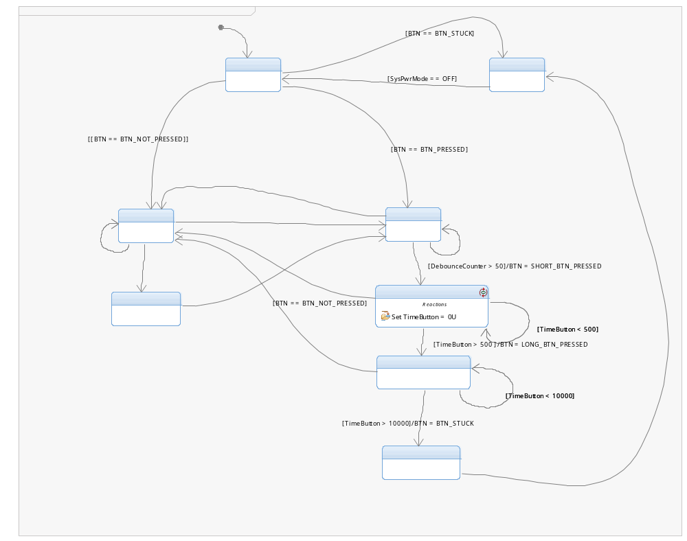

Function void DigitalInputManager_ButtonDoorStates (void)
Description | This function is executed periodically. The execution is implemented with a state machine to show the possible states of a door button (PRESSED, and NOT_PRESSED)
Parameter 1  <input| output| inout> | NA – Not identified yet
Parameter 2..n | NA – Not identified yet
Return Value | void
Precondition | Function is called by the OS.
Post condition | Door software component will received the most recent values from the buttons.
Error Conditions | NA – Not identified yet
Requirements | NA – Not identified yet

Dynamic Behavior
State Chart¹

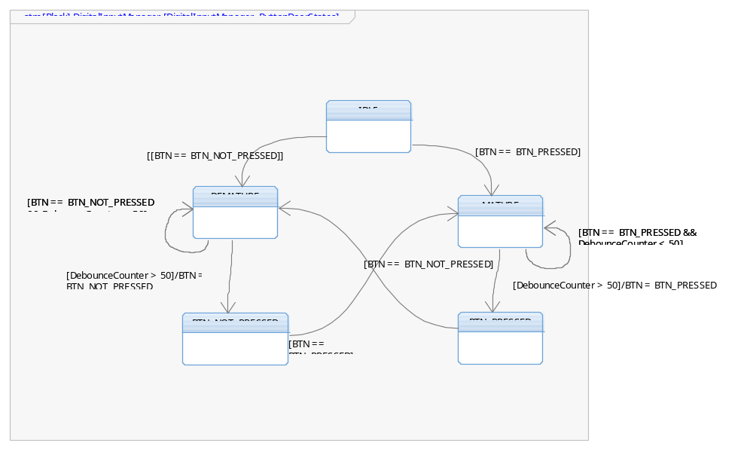

Function void DigitalInputManager_SwitchStates (void)
Description | This function is executed periodically. The execution is implemented with a state machine to show the possible states of door and window switches (PRESSED, and NOT_PRESSED)
Parameter 1  <input| output| inout> | NA – Not identified yet
Parameter 2..n | NA – Not identified yet
Return Value | void
Precondition | Function is called by the OS.
Post condition | Door and window software components will received the most recent values from the switches.
Error Conditions | NA – Not identified yet
Requirements | NA – Not identified yet

Dynamic Behavior
State Chart¹

